DevOps and Cloud
Miniproject : Unit 3
ENTERPRISE SMART LIBRARY MANAGEMENT PLATFORM
Name : Sakhee Balasaheb Sonawane
PRN : 2125UDSF1011
Dept : SY – AIDS
GIt Hub LInk:https://github.com/Sakhee11/student-academic-platform.git
https://github.com/Sakhee11/SU-DevOps.git

Project Documentation Report
Project Title: Enterprise Smart Library Management Platform
Technology Stack: Python, Flask, Pytest, Git, GitHub, Jenkins, Docker, Kubernetes, Minikube
Project Type: DevOps Mini Project
1.Introduction

The Enterprise Smart Library Management Platform is a web application developed using Python and Flask. It provides basic library management features such as viewing books, adding new books, borrowing books, and returning books.
DevOps tools are used to manage the source code, test the application, build a Docker image, and deploy the application in a Kubernetes environment. Jenkins is used to automate the continuous integration process.

2. Objectives

The main objectives of this project are:
- To develop a library management application using Python and Flask.
- To maintain source code using Git and GitHub.
- To perform code quality checks and unit testing.
- To package the application using Docker.
- To configure a Jenkins CI pipeline.
- To deploy the application using Kubernetes and Minikube.
- To verify application health and API responses.

3. Software and Environment Requirements
The project uses the following software and tools.
Tool | Purpose
Ubuntu | Operating system
Python | Application development
Flask | Web application framework
Pytest | Unit testing
Git and GitHub | Version control and source code hosting
Jenkins | Continuous integration
Docker | Containerization
Kubernetes | Container orchestration
Minikube | Local Kubernetes environment
kubectl | Kubernetes cluster management

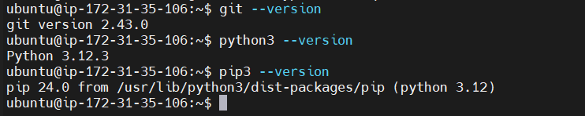
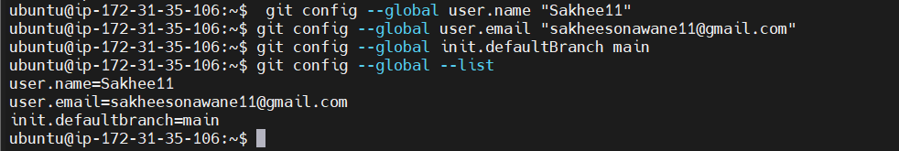

4. Source Code Management Using Git and GitHub

Git is used to track changes in the project source code, while GitHub hosts the repository remotely. The project repository contains the application code, testing files, dependency requirements, Dockerfile, Jenkinsfile, and Kubernetes configuration files.
Commands used to inspect the repository include:

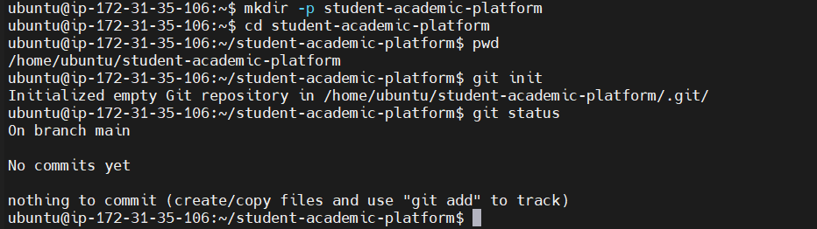

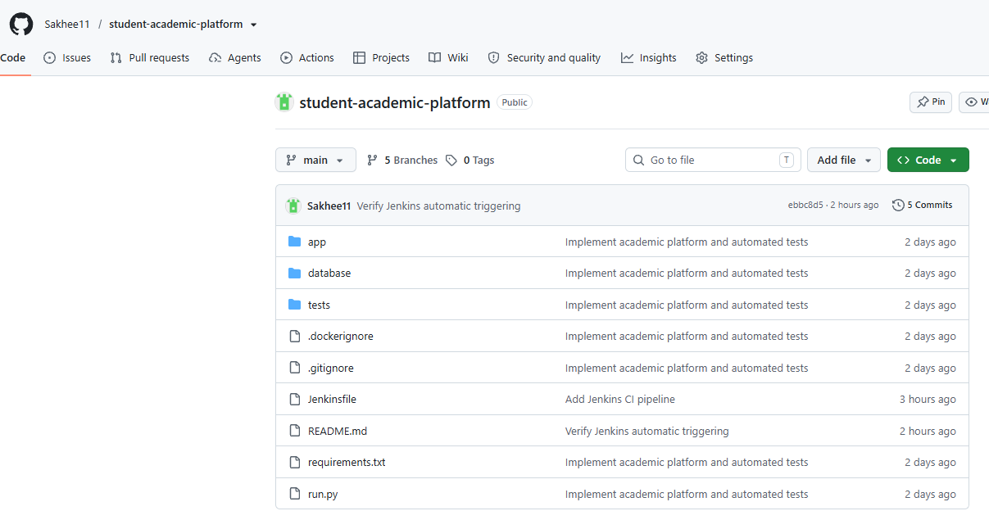

Complete Application Source Code

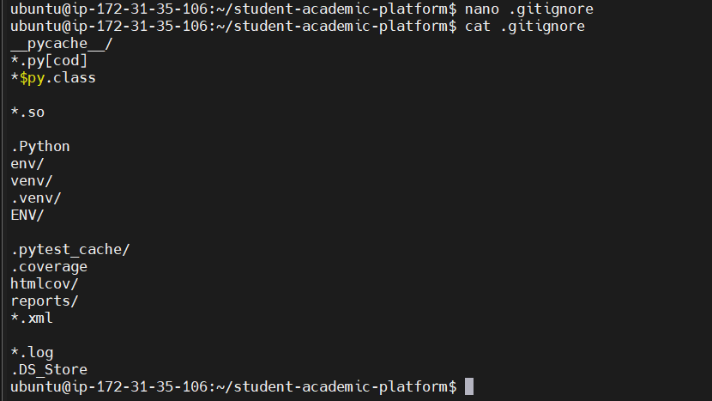

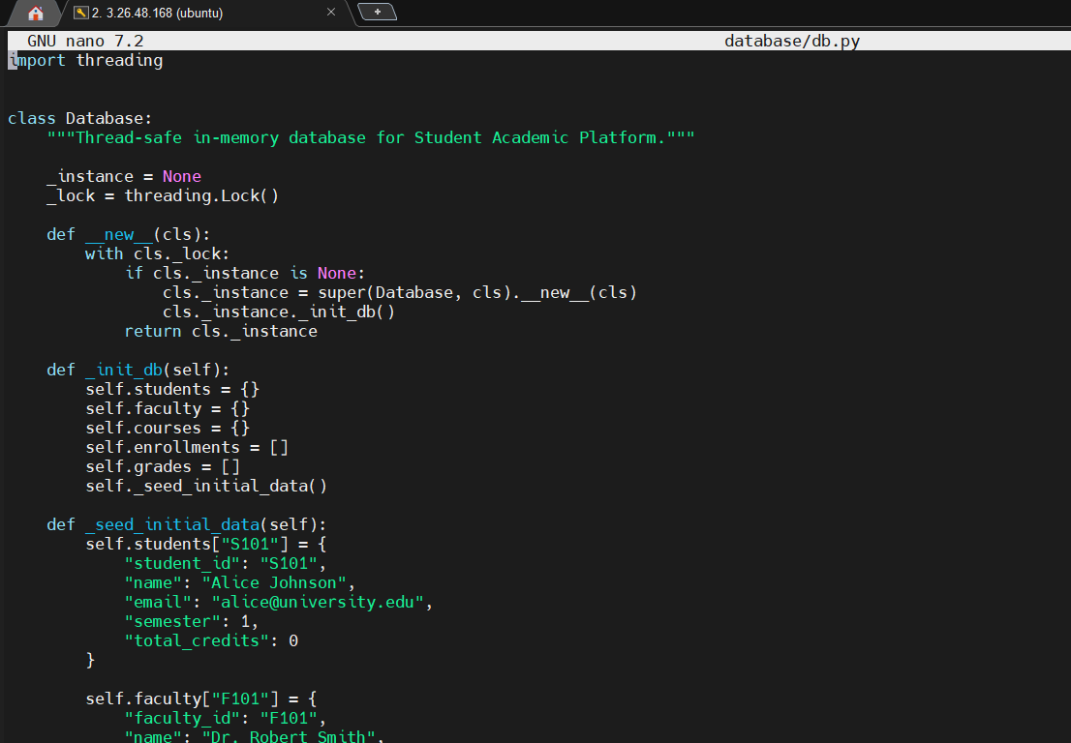

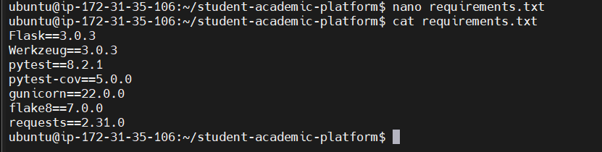

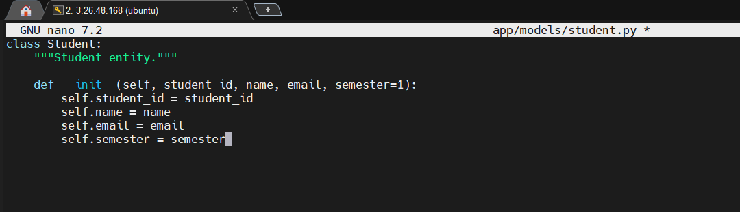

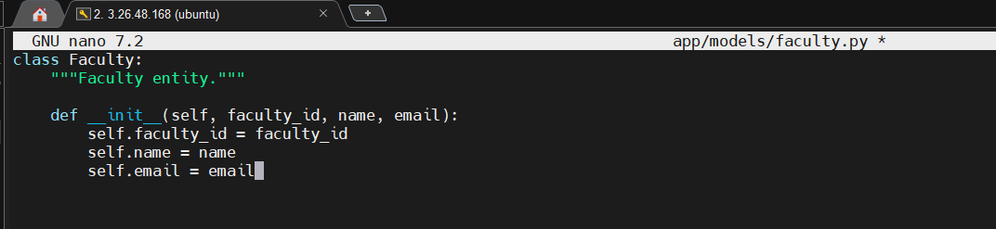

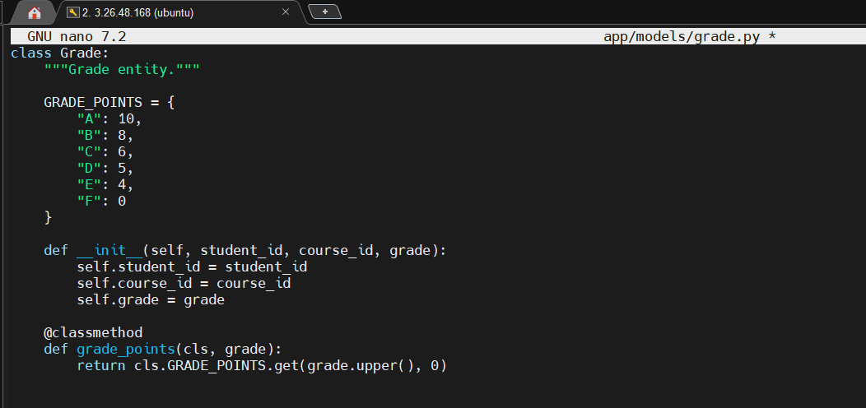

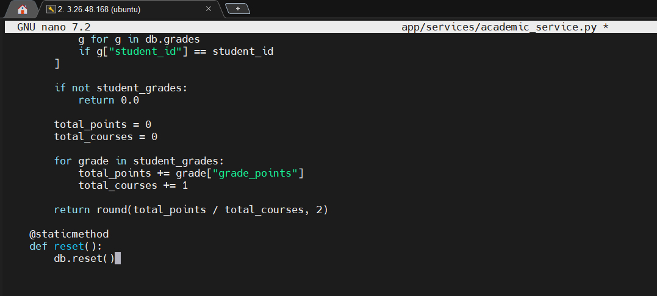

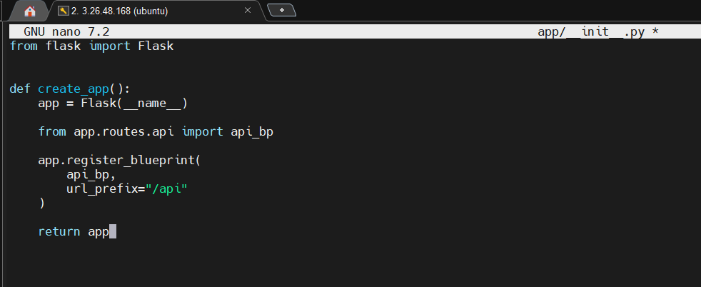

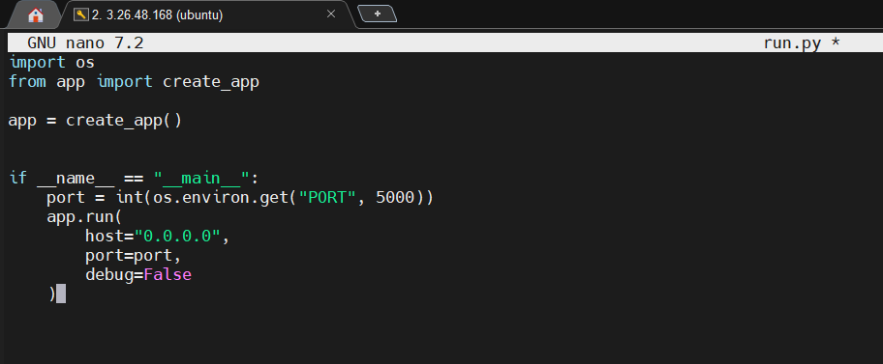
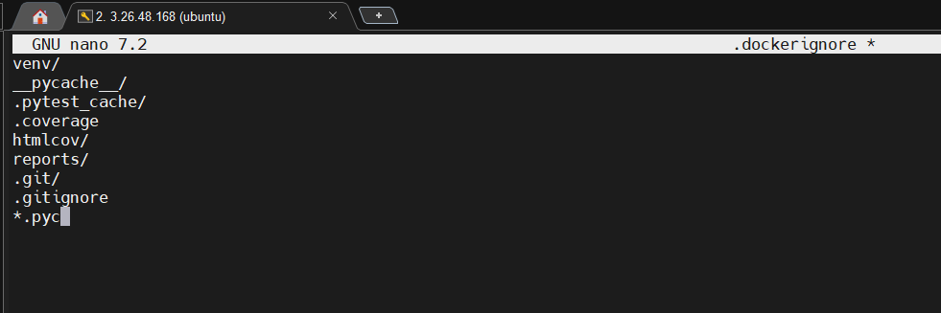
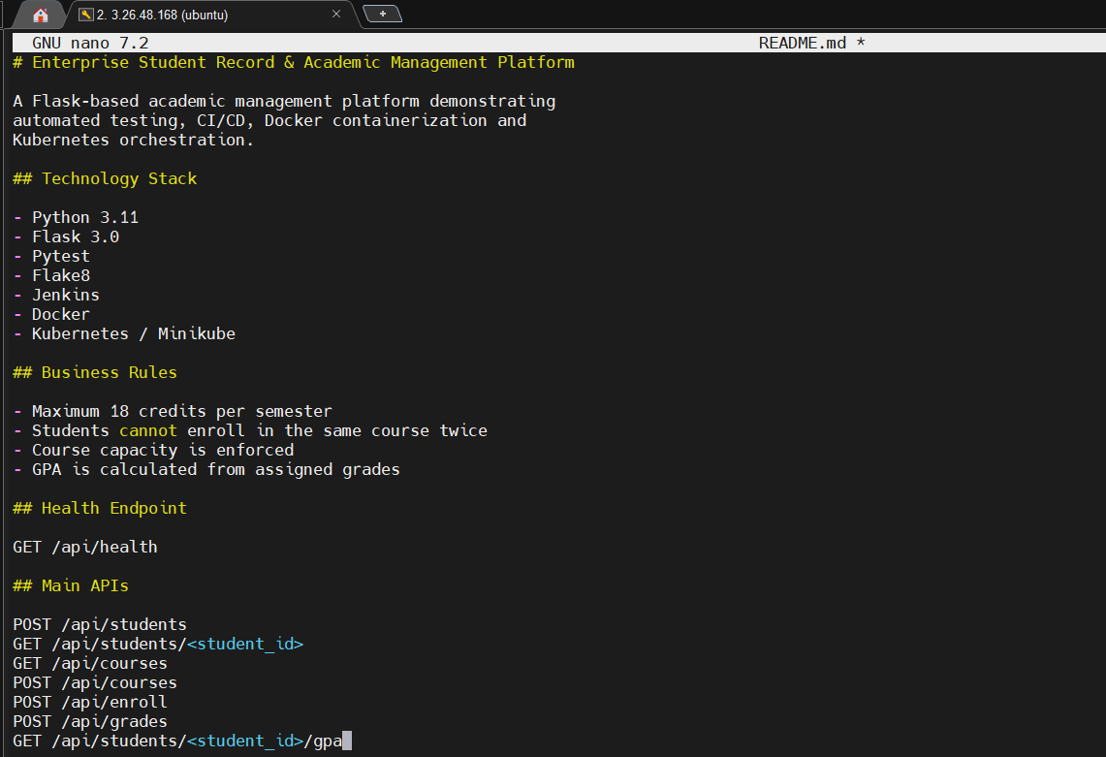

5. Application Development and Testing

The application is developed using Python and Flask. It provides endpoints for checking application health and managing book records.
The health endpoint is used to check whether the application is responding correctly. Pytest is used to execute unit tests for the application's functionality.
The test cases cover the home page, health endpoint, book listing, adding books, borrowing and returning books, and handling invalid requests.
Command used to execute tests:

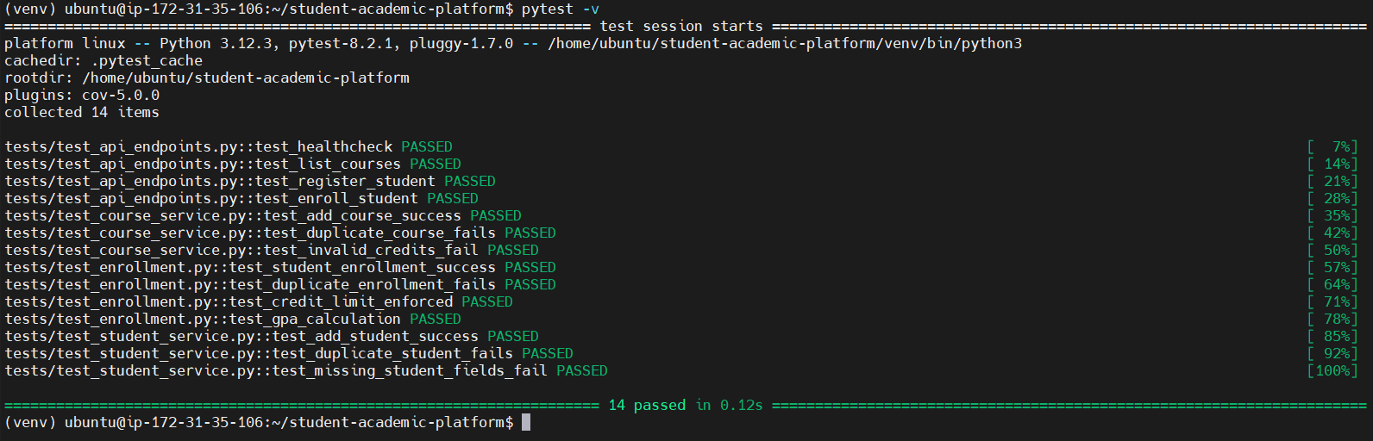

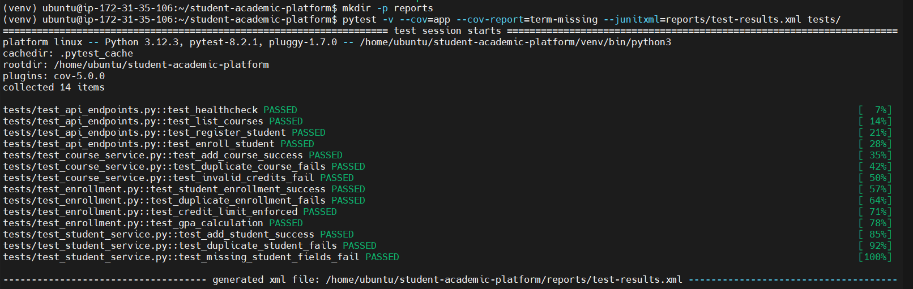

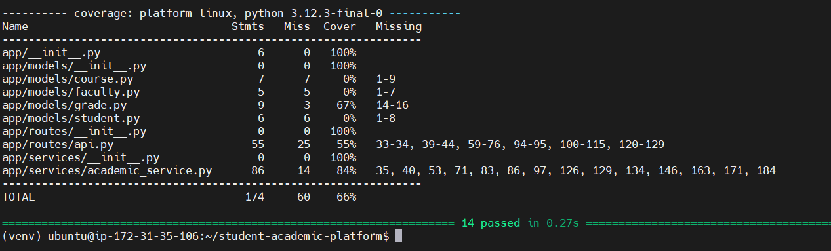

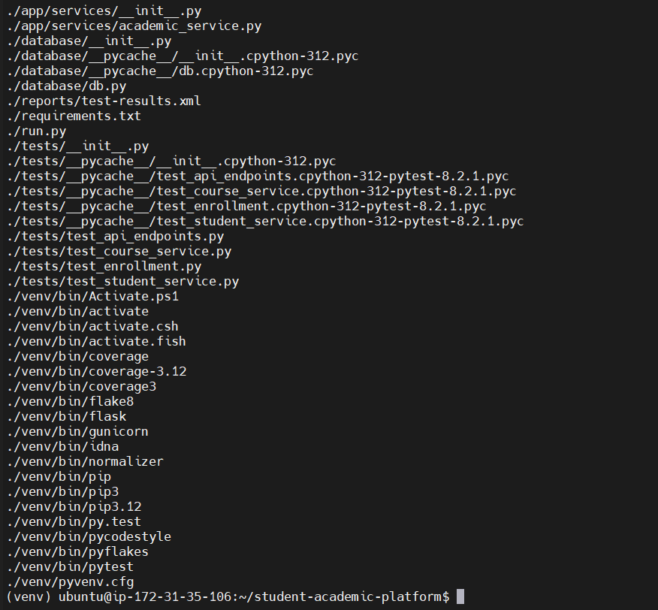

6. Continuous Integration Using Jenkins

Jenkins is used to automate the continuous integration process. The pipeline retrieves the source code and executes the required development and testing stages.
The configured pipeline includes:
- Checkout source code.
- Set up the Python environment.
- Install project dependencies.
- Perform code linting using Flake8.
- Execute unit tests using Pytest.
- Build the Docker image.

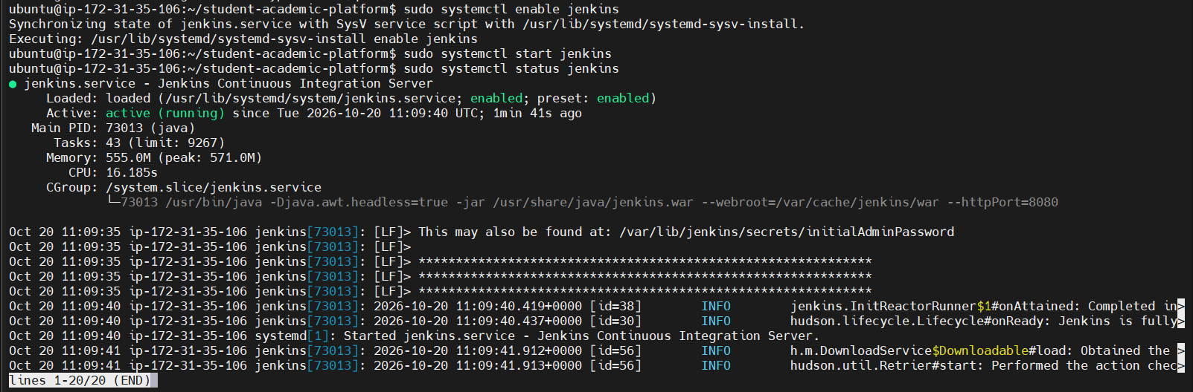

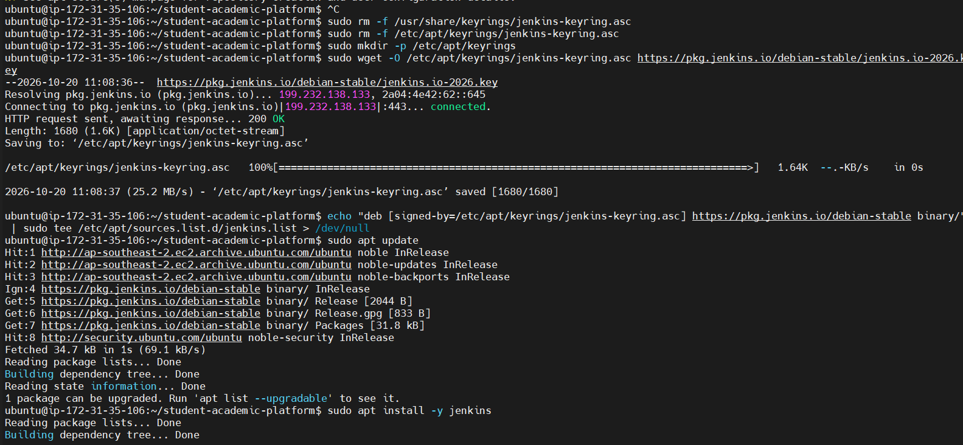

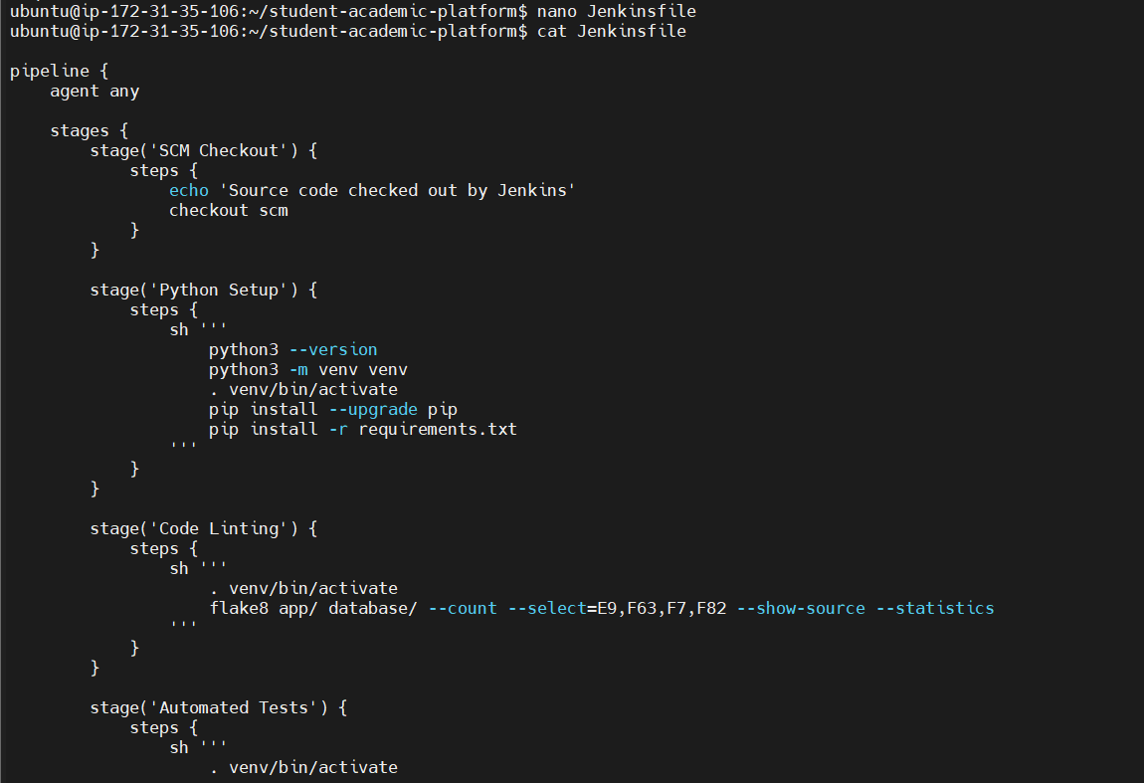

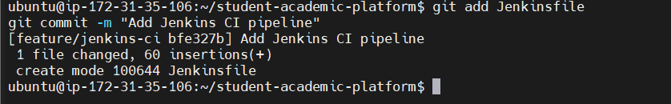

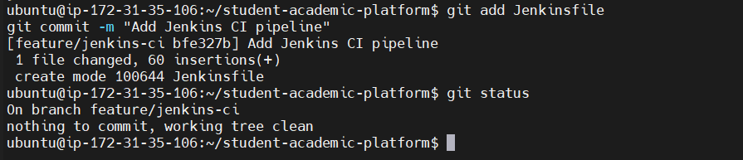

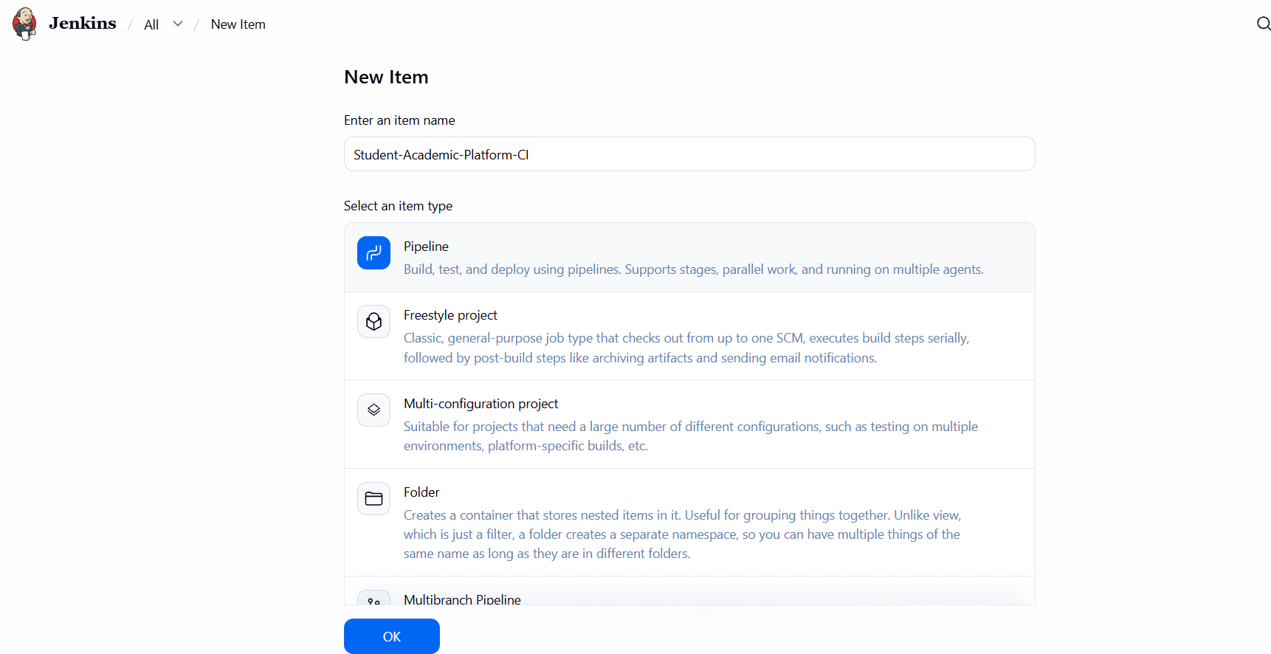

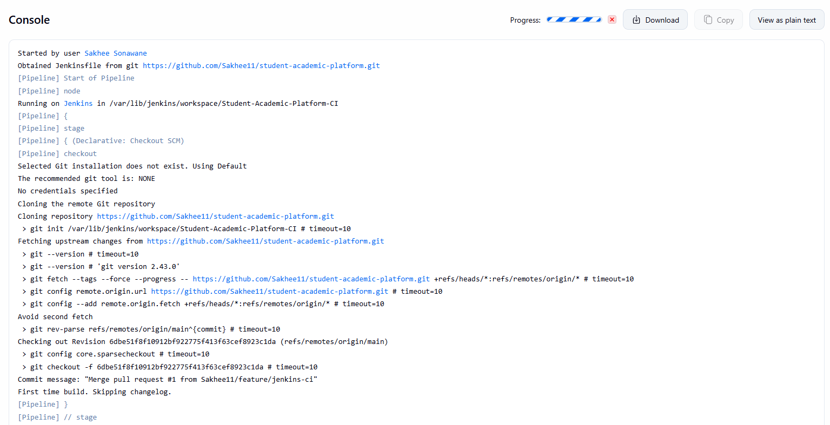

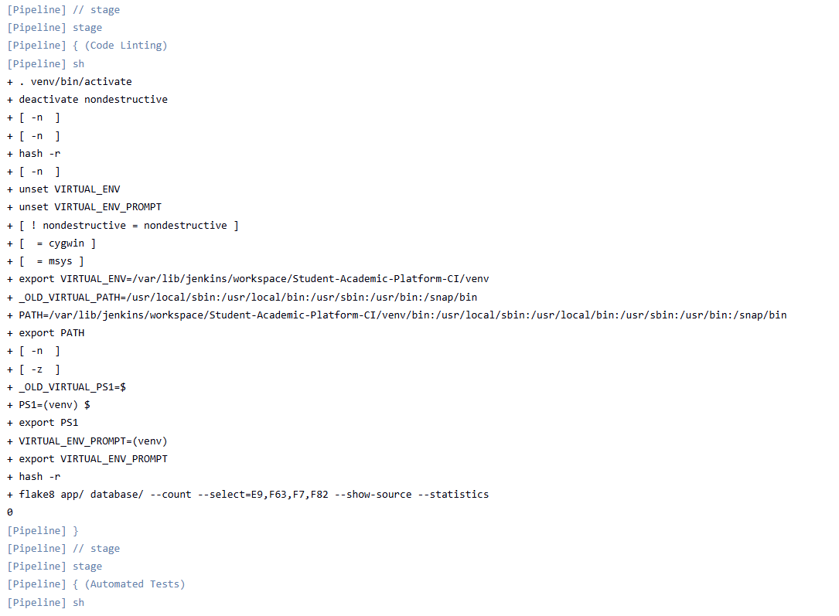

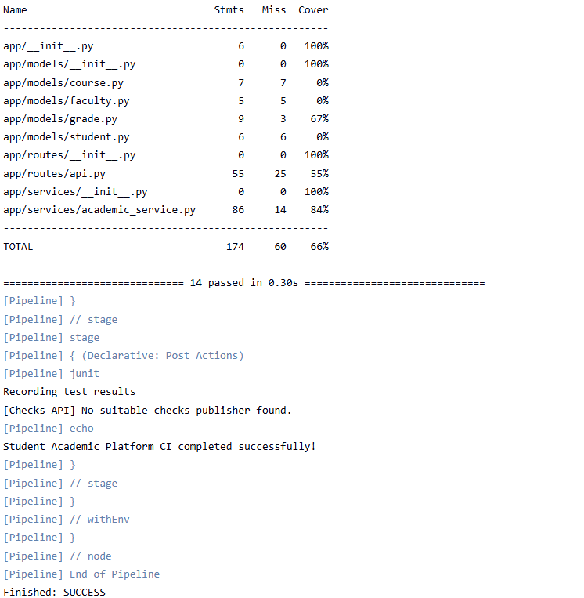
- Containerization Using Docker

Docker is used to package the application and its required environment into a container image. This helps run the application consistently across supported environments.
The project Docker image is tagged:
library-platform:v1.0.0
Commands used to inspect Docker images and running containers:

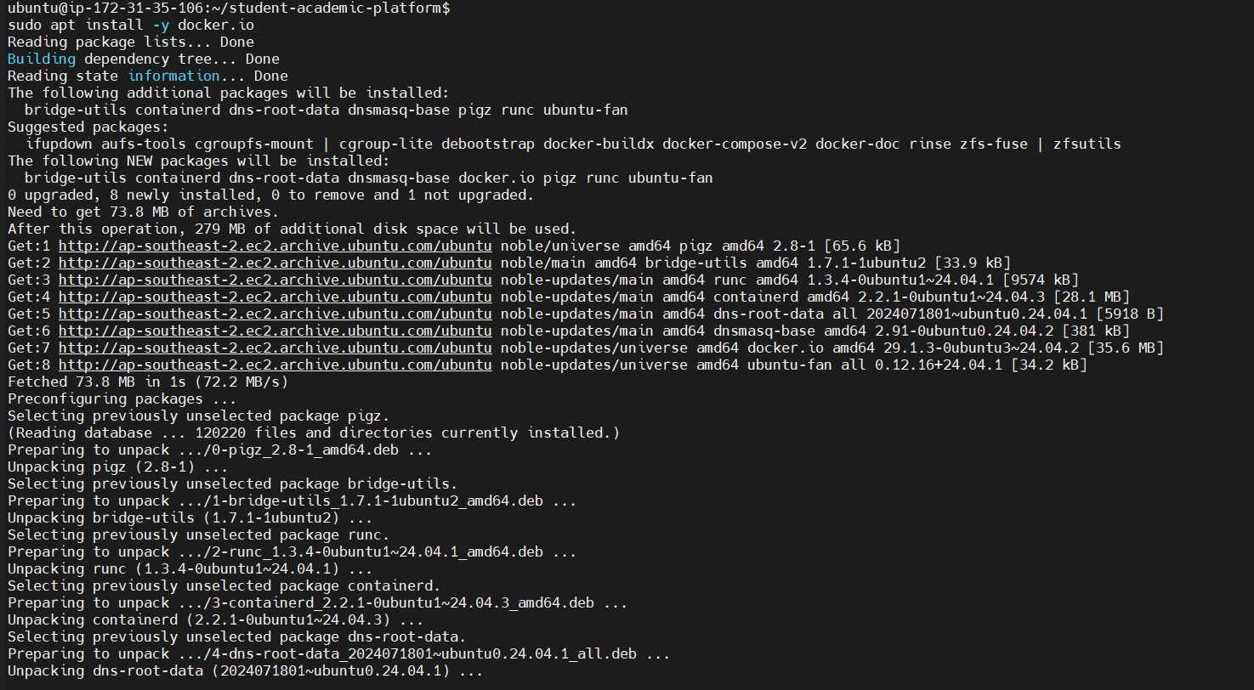

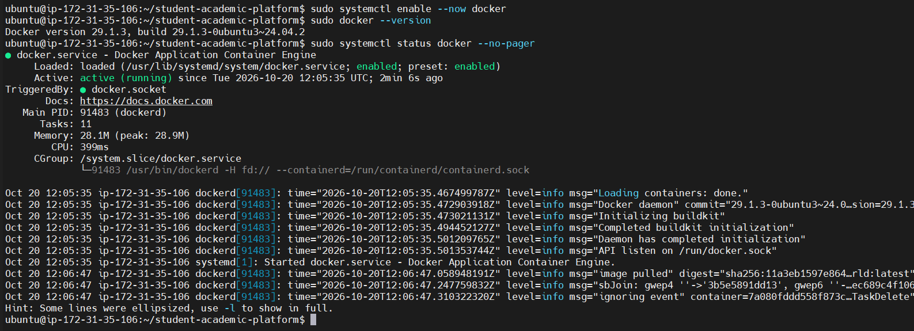

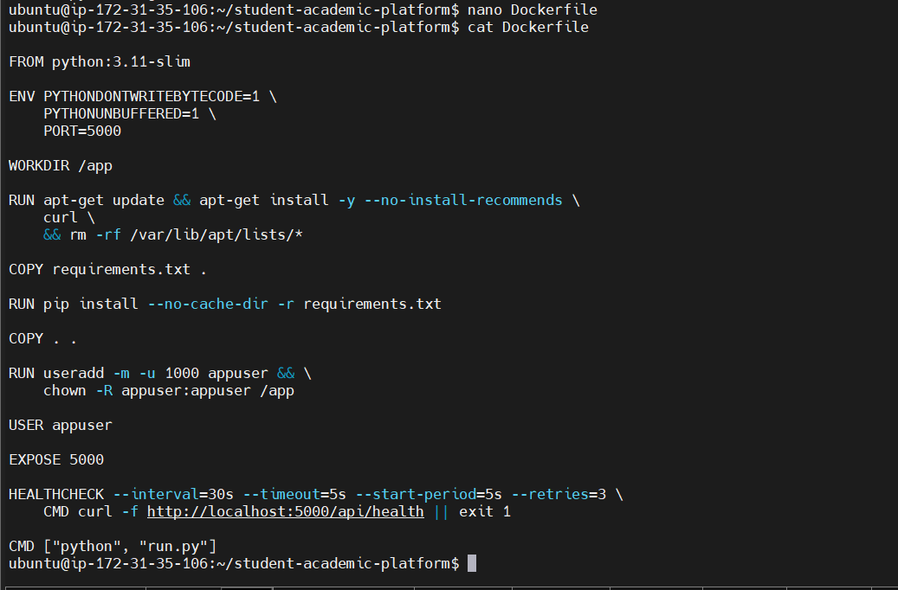

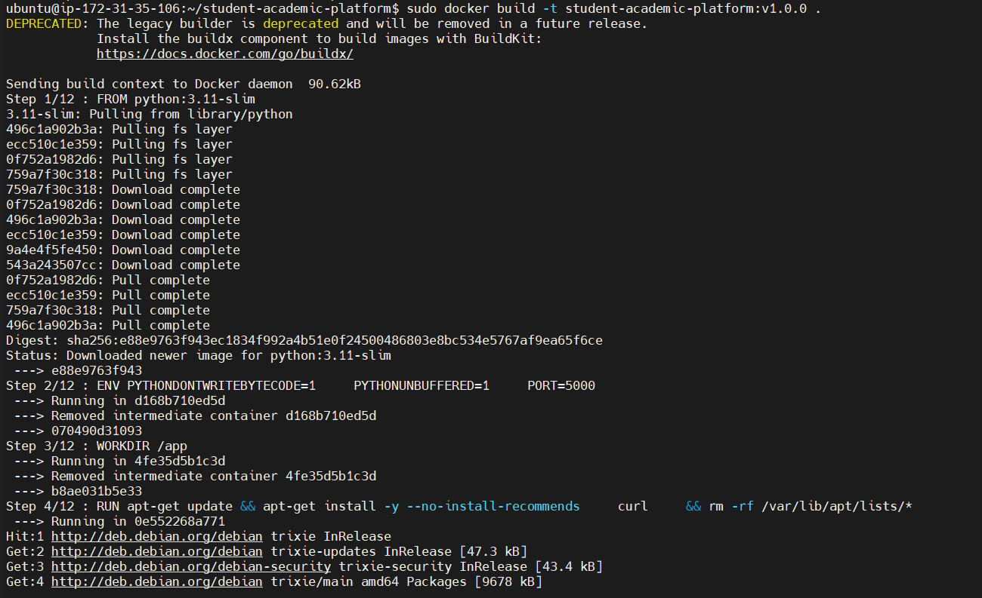

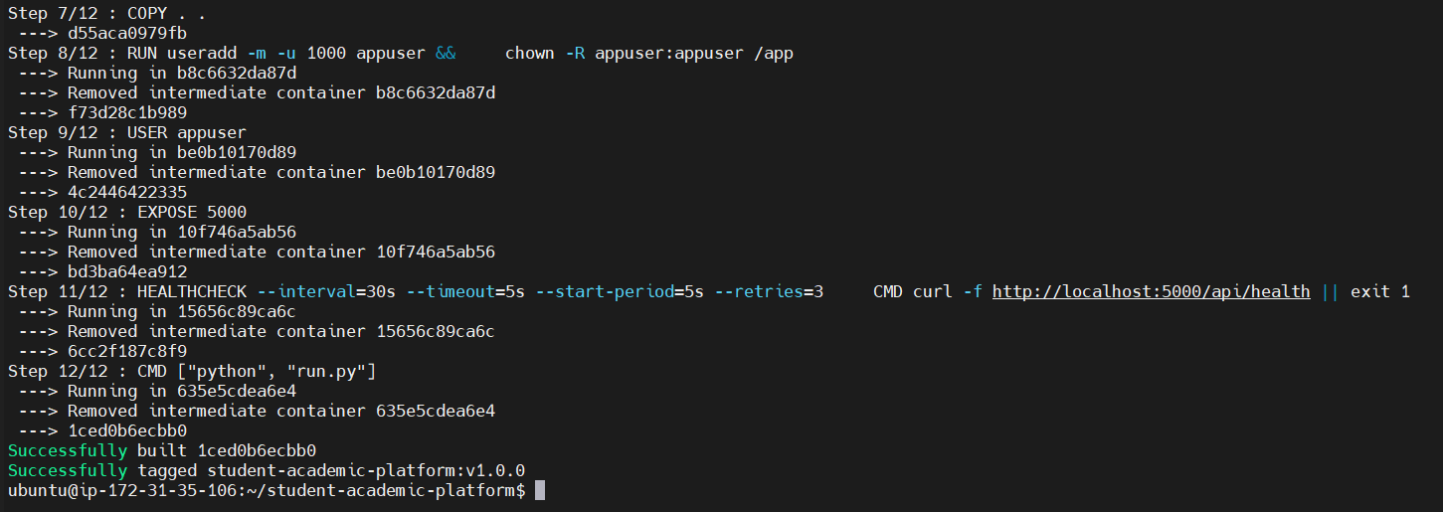
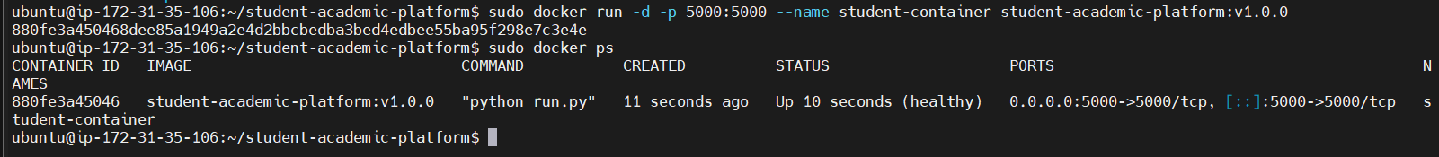

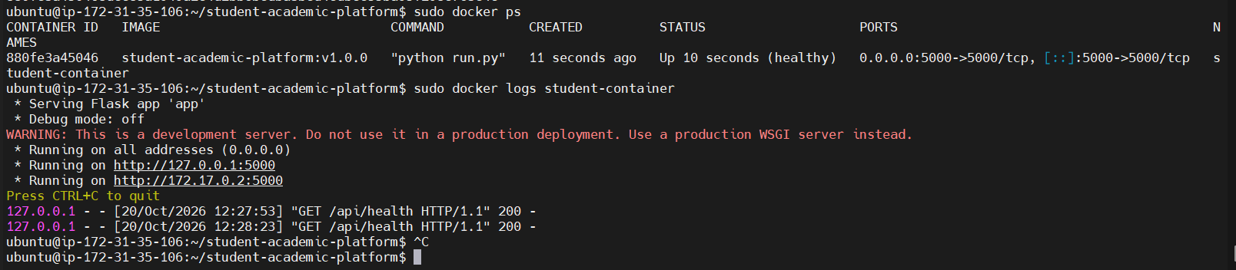

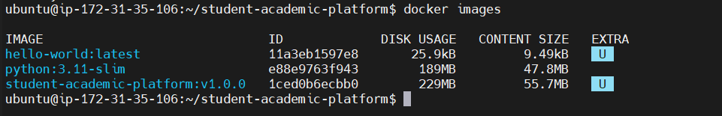

- Kubernetes Deployment Using Minikube

Minikube provides a local Kubernetes cluster for deploying and testing the application. Kubernetes manages the application deployment and exposes it through a Service.
The deployment is named smart-library, and the Service is named smart-library-service. The configured NodePort is 30080.
Commands used to verify the Kubernetes environment:

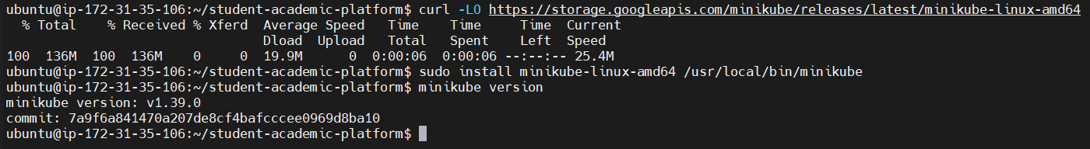

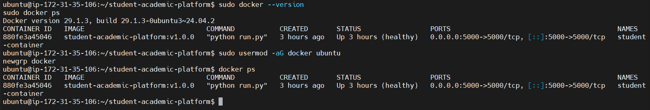

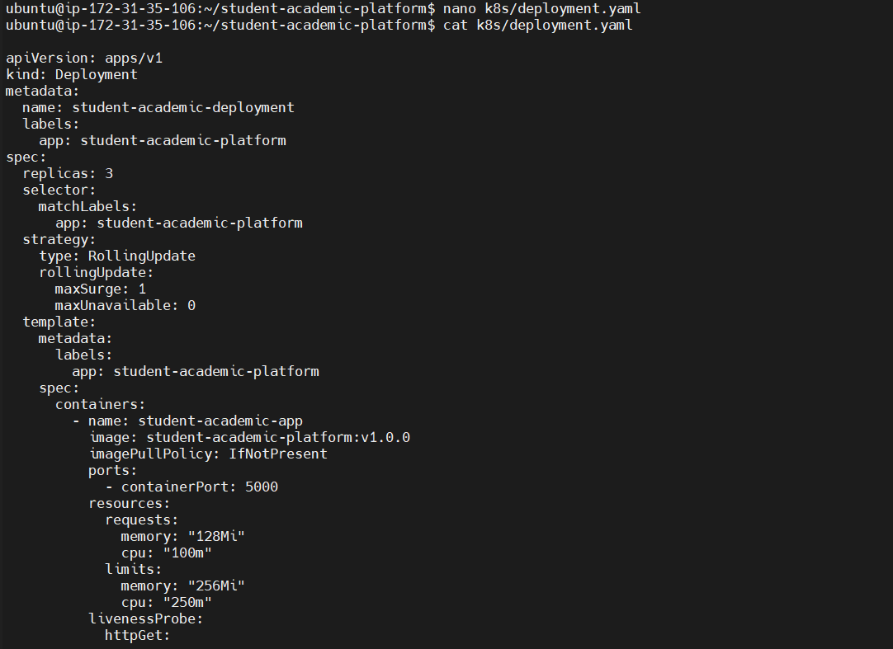

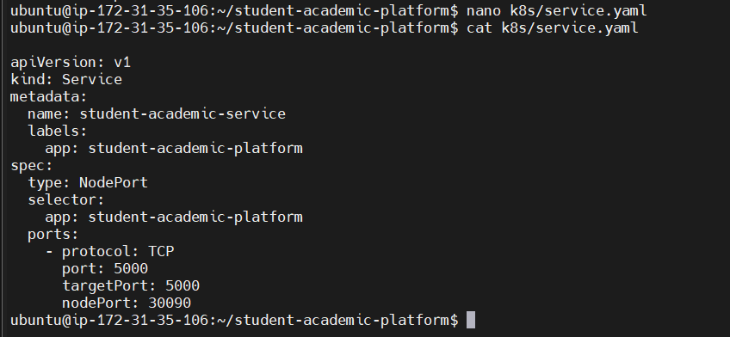
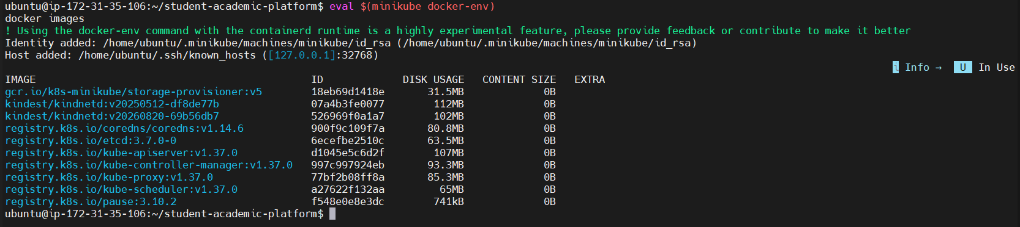

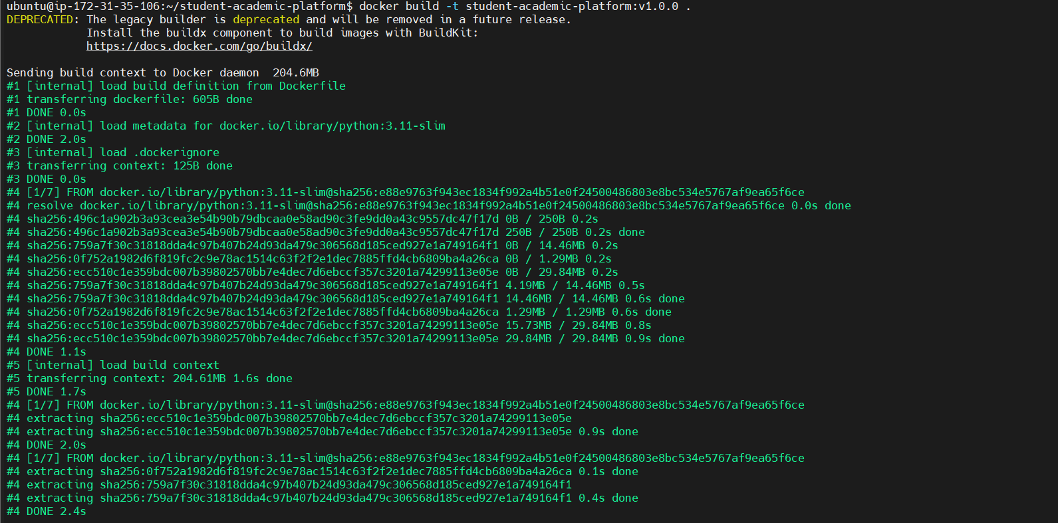

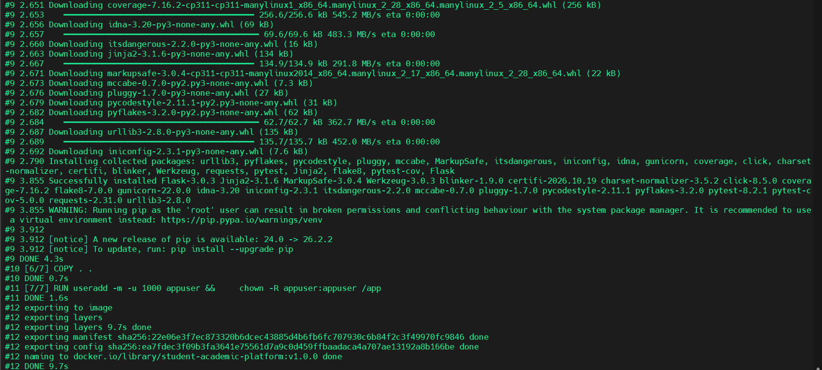

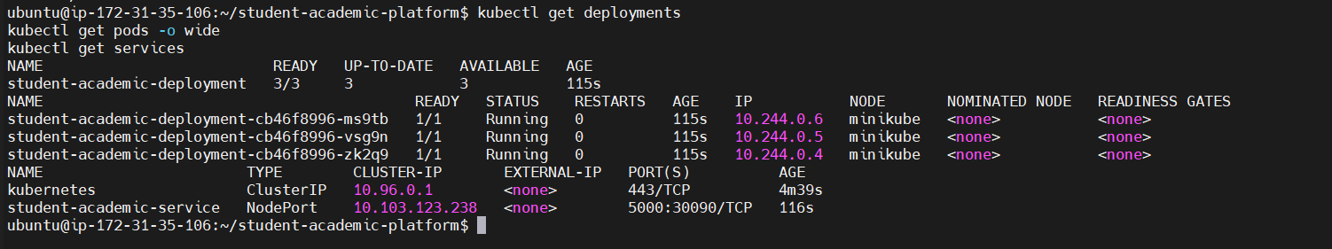

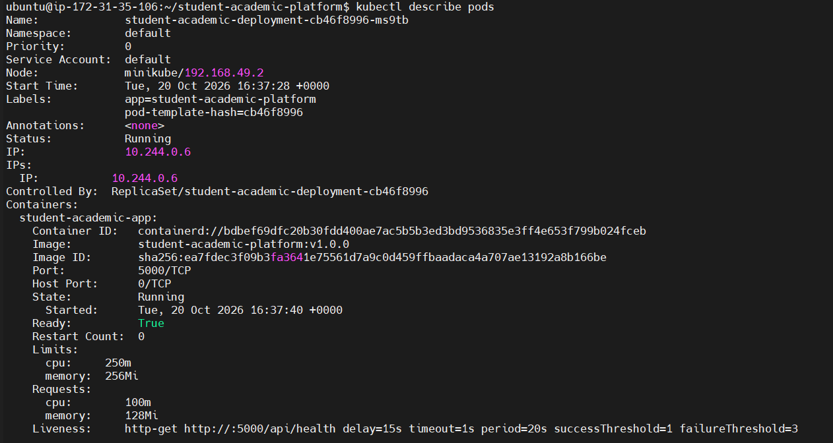

- Application Verification

The application is verified by checking its health endpoint and retrieving the list of books through the Kubernetes Service.
Commands:

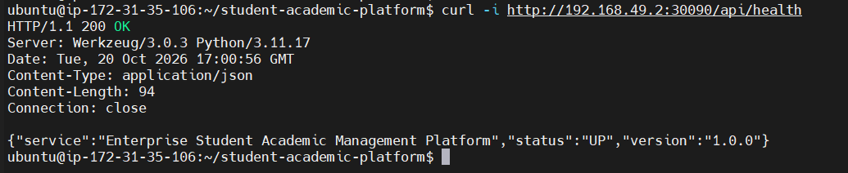
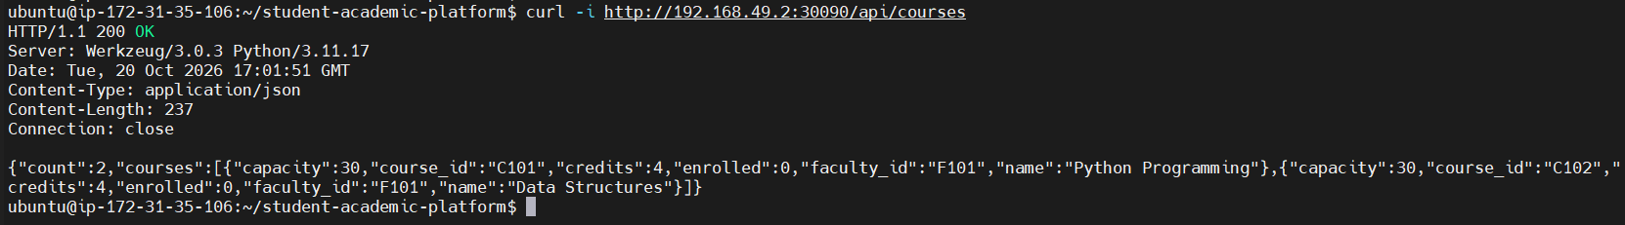

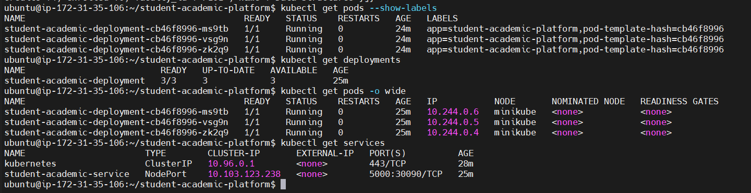

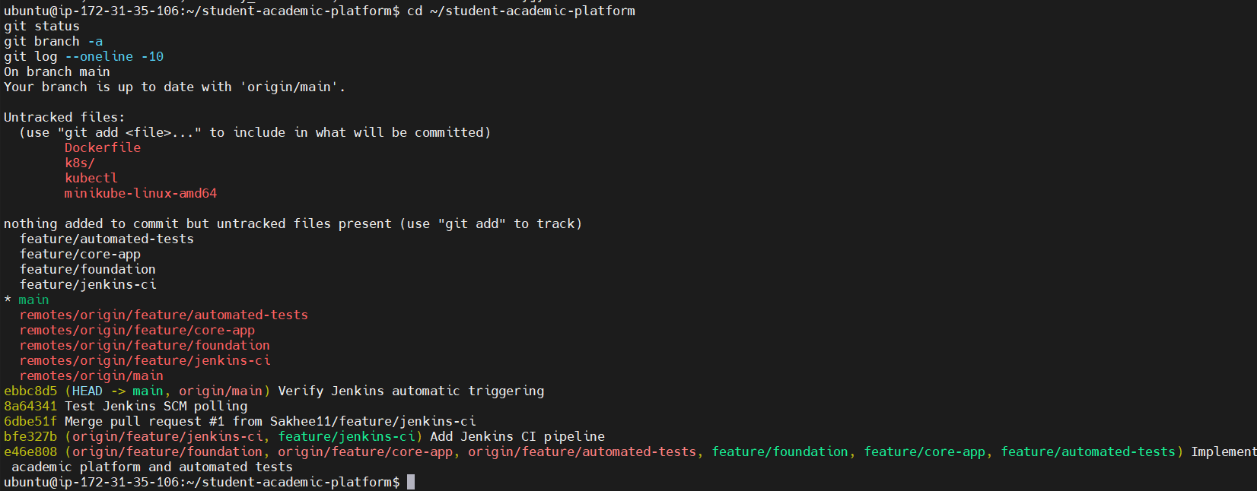

- Results and Discussion

The project demonstrates the use of DevOps tools in the software development and deployment lifecycle. The application was tested using Pytest, the source code was managed using Git and GitHub, and Jenkins was configured to automate code checking, testing, and Docker image building.
The application was also deployed in the Minikube Kubernetes environment and verified through its health and books endpoints.
Only include results that are confirmed by your screenshots and command outputs.

- Conclusion

The Enterprise Smart Library Management Platform demonstrates how application development can be combined with DevOps practices. GitHub supports source code management, Jenkins automates the CI pipeline, Docker packages the application, and Kubernetes manages deployment. The project provides practical experience with testing, containerization, deployment, and application verification.
- Future Scope

The project can be extended by adding a database, user authentication, a graphical user interface, automated deployment after successful builds, container registry integration, and monitoring tools.

